**BASIC SQL**

**Exercises**

**Exercises:**

1. Using the Global Fast Foods database, retrieve the customer’s first name, last name, and address for the customer who uses ID 456.

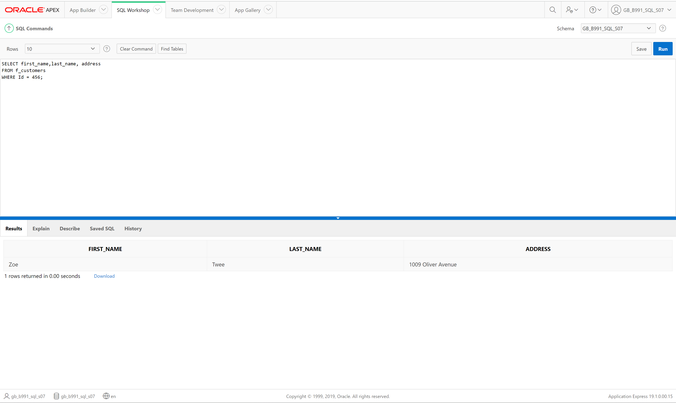

1. Select Department name from Departments where location ID <1200

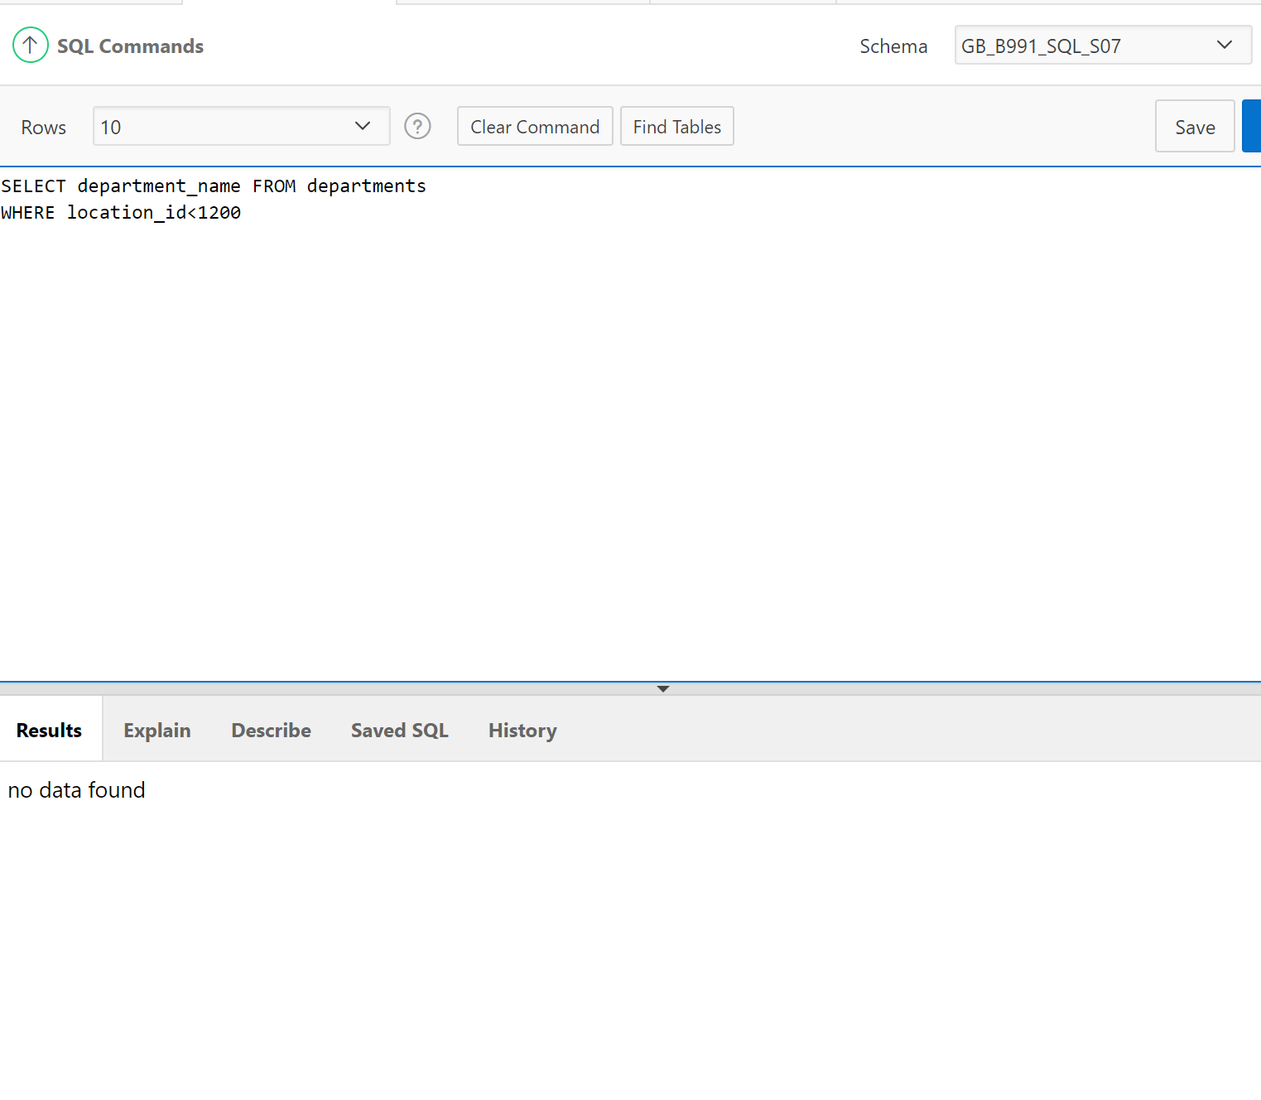

1. Select First name and last name from Employees concatenate them and give them a title of “FULL EMPLOYEE NAME”

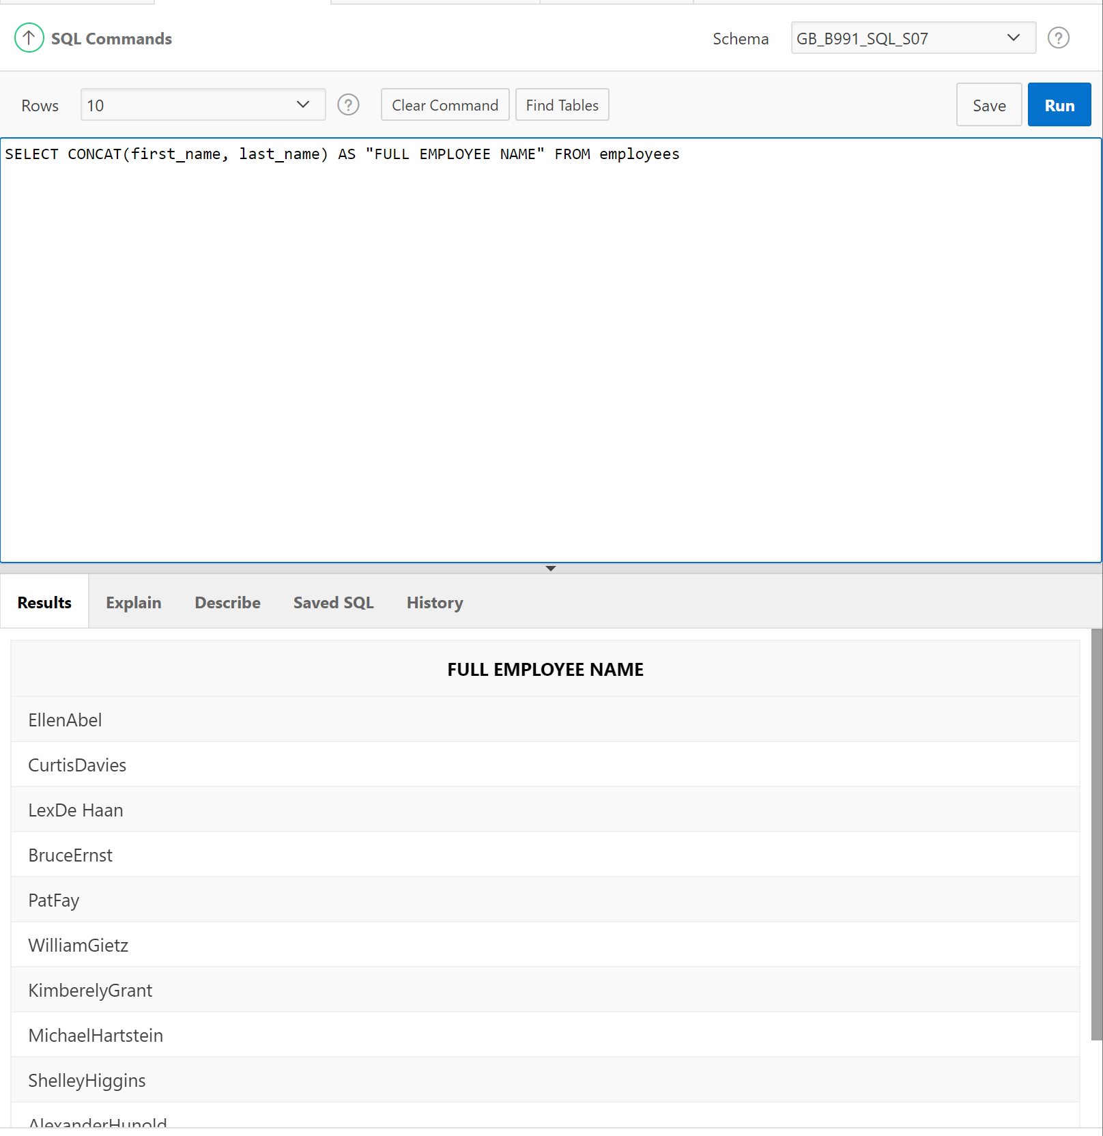

1. Select minimum salary from Jobs where Job Title is Administration Assistant

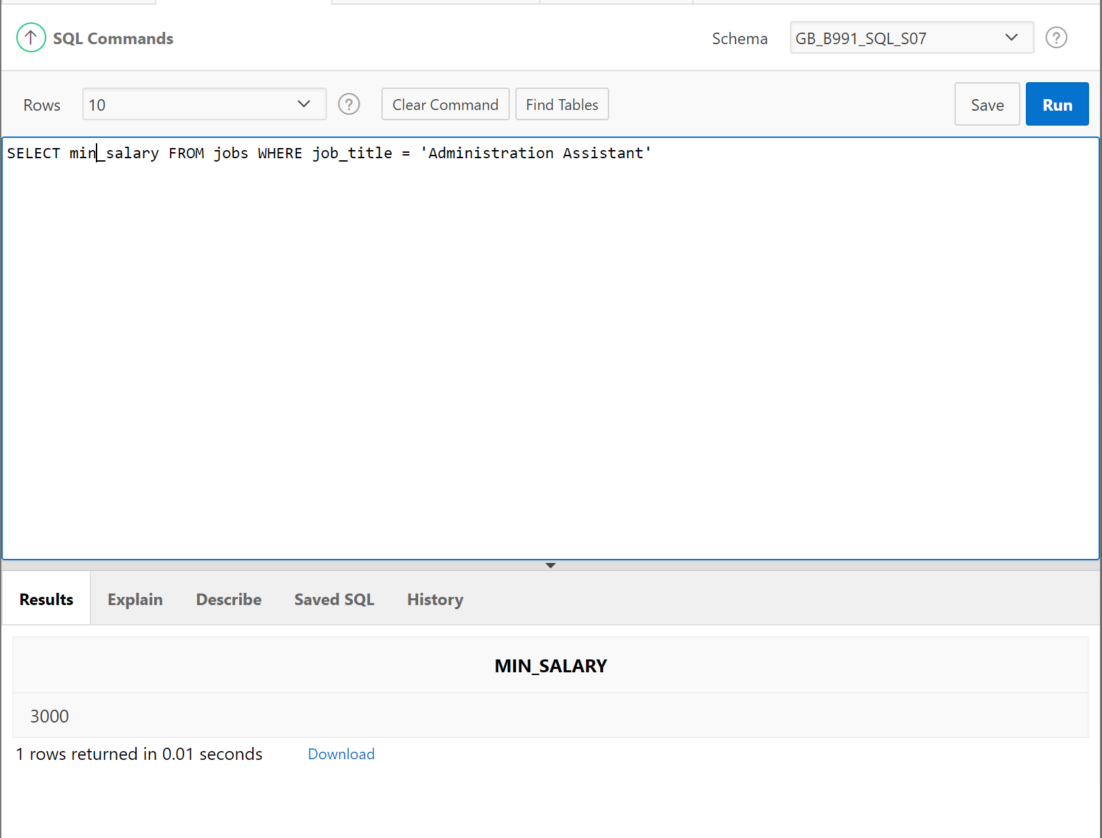

1. Show the name, start date, and end date for Global Fast Foods' promotional item “ballpen and highlighter” giveaway.

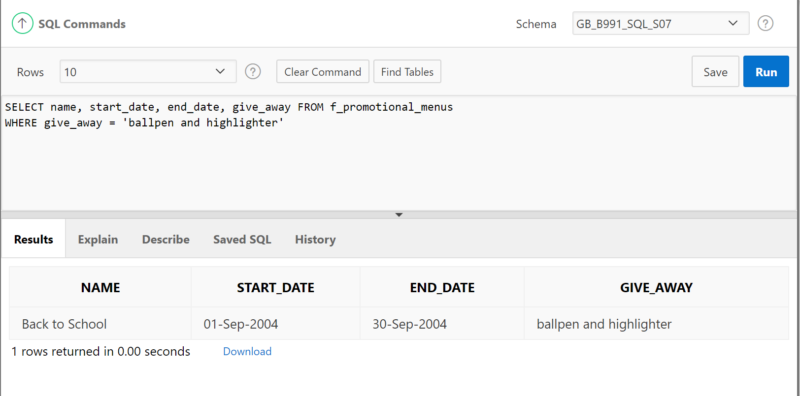

1. Create a SQL statement that produces the following output:

Oldest

The 1997 recording in our database is The Celebrants Live in Concert

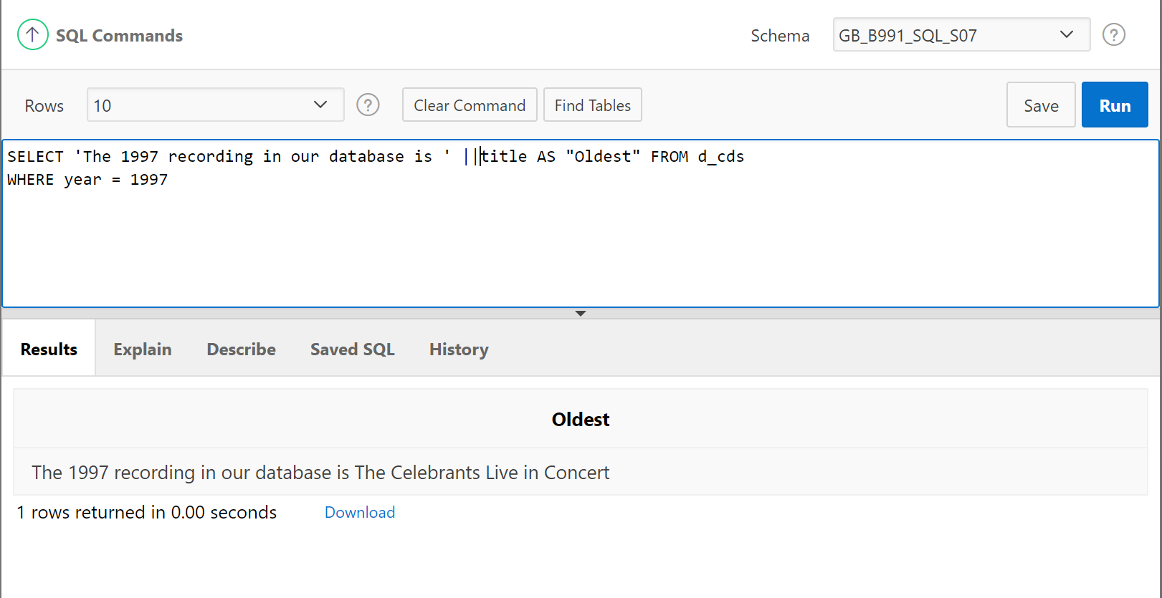

1. The following query was supposed to return the CD title "Carpe Diem" but no rows were returned. Correct the mistake in the statement and show the output.

*SELECT produce, title FROM d_cds*

*WHERE title = 'carpe diem' ;*

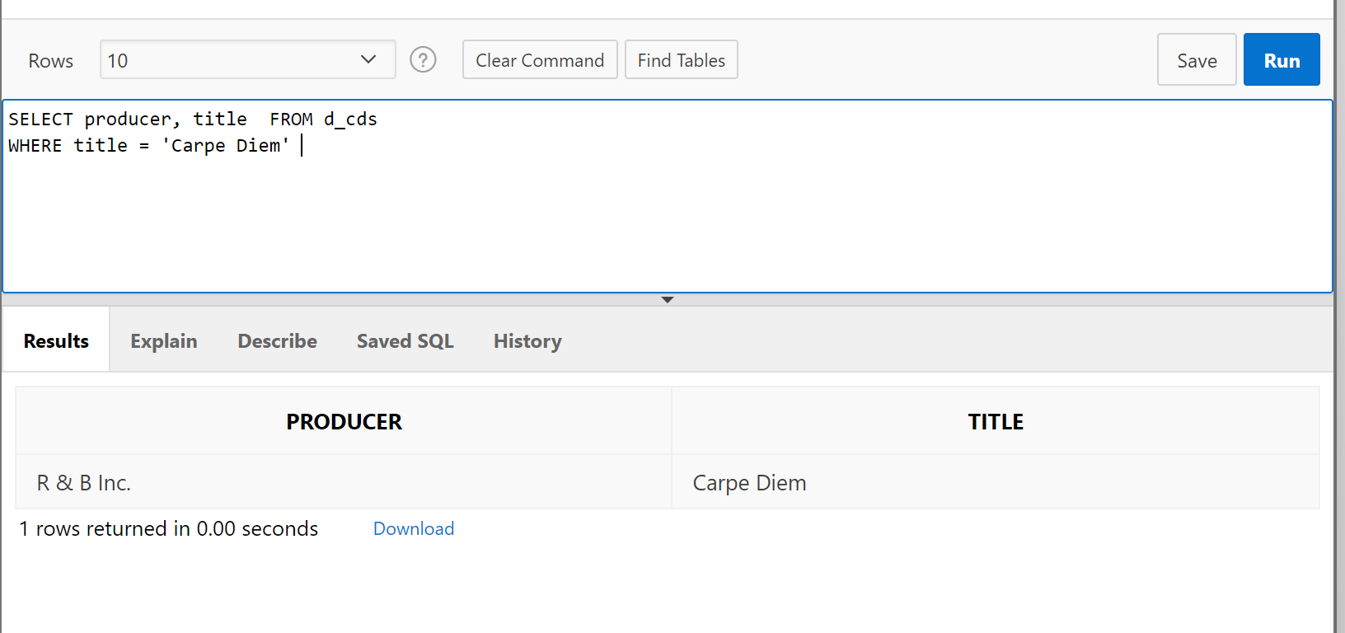

1. Write a SQL statement that will display the student number (studentno), first name (fname), and last name (lname) for all students who are female (F) in the table named students.

SELECT studentno, fname, lname

FROM students WHERE sex = 'F'

1. Write a SQL statement that will display the student number (studentno) of any student who has a

PE major in the table named students. Title the studentno column Student Number.

SELECT studentno AS 'Student Number'

FROM students WHERE major = 'PE'

1. Write a SQL statement that lists all information about all male students in the table named students.

SELECT * as FROM students WHERE sex= 'M'

1. Write a SQL statement that will list the titles and years of all the DJs on Demand's CDs that were not produced in 2000.

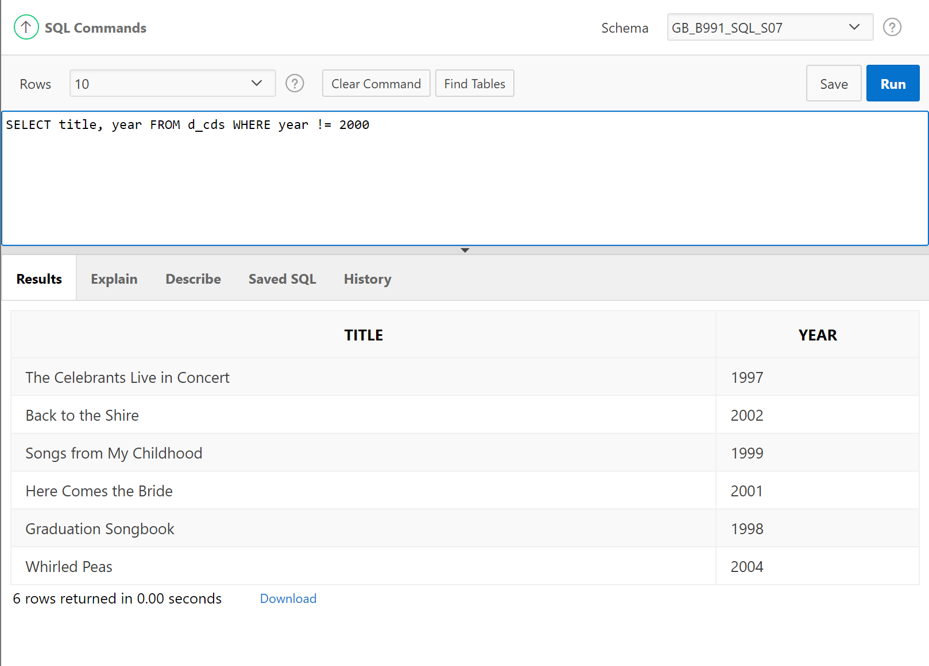

1. Write a SQL statement that lists the Global Fast Foods employees who were born before 1980.

